8.3.1 Editors - Image Editor - Sidebar - Tools Tab in Paint Mode
Detailed Table of Content 1
Tools Tab 6
Save Image 6
Brushes Panel 6
Browse Brush 6
Custom Icon 7
Brush settings Panel 7
Brush Panel 7
Brush Settings Panel - Color Picker Sub panel 8
Brush colors flip 8
Use unified Color 8
Brush Settings Panel - Color Palette Sub panel 9
Palette browser 9
Edit Box 9
Number of users 9
Fake User 9
Add palette 9
Remove Palette 9
Brush Settings Panel - Advanced Sub panel 10
Accumulate 10
Affect Alpha 10
Sharpen / Soften (Soften Brush) 10
Blur Mode (Soften Brush) 10
Image (Clone Brush) 10
Anti Aliasing 10
Mask Value (Mask brush) 10
Brush Settings Panel - Texture Sub panel 11
Texture Panel 11
Brush Settings Panel - Texture Mask Sub panel 15
Texture Mask Panel 15
Stroke Panel 19
Stroke Panel 19
Brush Settings Panel - Falloff Sub panel 26
Selecting Points 26
Adding Points 26
Navigation elements 27
Brush Settings Panel - Brush Tip Sub panel 28
Brush Tip Checkbox 28
Cursor Color 28
Falloff Opacity 28
Texture Opacity 28
Mask Texture Opacity 29
Tiling panel 29

Detailed Table of Content

Detailed Table of Content
Detailed Table of Content 1
Tools Tab 6
Save Image 6
Brushes Panel 6
Browse Brush 6
Custom Icon 7
Brush settings Panel 7
Brush Panel 7
Blend 7
Radius 8
Size Pressure 8
Use Unified Radius 8
Strength 8
Size Pressure 8
Use Unified Radius 8
Brush Settings Panel - Color Picker Sub panel 8
Brush colors flip 8
Use unified Color 8
Brush Settings Panel - Color Palette Sub panel 9
Palette browser 9
Edit Box 9
Number of users 9
Fake User 9
Add palette 9
Remove Palette 9
Brush Settings Panel - Advanced Sub panel 10
Accumulate 10
Affect Alpha 10
Sharpen / Soften (Soften Brush) 10
Sharp Threshold 10
Kernel Radius 10
Blur Mode (Soften Brush) 10
Image (Clone Brush) 10
Alpha 10
Anti Aliasing 10
Mask Value (Mask brush) 10
Brush Settings Panel - Texture Sub panel 11
Texture Panel 11
Browse Texture to be linked 11
Texture Edit box 12
Brush Mapping 12
Brush Mapping with mapping method Tiled 13
Angle 13
Offset 13
Size 13
Brush Mapping with mapping method View Plane 13
Angle 13
Rake 13
Random 13
Offset 13
Size 13
Brush Mapping with mapping method 3D 14
Offset 14
Size 14
Brush Mapping with mapping method Random 14
Angle 14
Rake 14
Random 14
Brush Mapping with mapping method Stencil 14
Image Aspect 15
Reset Transform 15
Angle edit box 15
Offset 15
Size 15
Brush Settings Panel - Texture Mask Sub panel 15
Texture Mask Panel 15
Browse Texture to be linked 16
Brush Mapping with mapping method Tiled 17
Pressure Masking 17
Angle 17
Offset 17
Size 17
Brush Mapping with mapping method View Plane 17
Pressure Masking 17
Angle 17
Rake 17
Random 17
Offset 18
Size 18
Brush Mapping with mapping method Random 18
Pressure Masking 18
Mask Pressure Mode 18
Angle 18
Rake 18
Random 18
Offset 18
Size 18
Brush Mapping with mapping method Stencil 18
Image Aspect 19
Reset Transform 19
Pressure Masking 19
Angle edit box 19
Offset 19
Size 19
Stroke Panel 19
Stroke Panel 19
Stroke method Space 19
Spacing Edit Box 20
Spacing Pressure 20
Adjust Strength for Spacing 20
Dash Ratio 20
Dash Length 20
Jitter Edit Box 20
Spacing Pressure 20
Jitter Unit 20
Input Samples Edit Box 20
Smooth Stroke 20
Smooth Stroke Radius Edit Box 20
Smooth Stroke Factor Edit Box 20
Stroke method Curve 21
Spacing Edit Box 21
Paint Curve edit box 21
Draw Curve Button 22
Jitter Edit Box 22
Jitter Pressure 22
Jitter Unit 22
Input Samples Edit Box 22
Stabilize Stroke 22
Smooth Stroke Radius Edit Box 22
Smooth Stroke Factor Edit Box 22
Stroke method Line 22
Spacing Edit Box 23
Jitter Edit Box 23
Jitter Pressure 23
Jitter Unit 23
Input Samples Edit Box 23
Stabilize Stroke 23
Smooth Stroke Radius Edit Box 23
Smooth Stroke Factor Edit Box 23
Stroke method Anchored 23
Edge to edge 23
Jitter Edit Box 23
Jitter Pressure 23
Jitter Unit 24
Input Sample Edit Box 24
Stabilize Stroke 24
Smooth Stroke Radius Edit Box 24
Smooth Stroke Factor Edit Box 24
Stroke method Airbrush 24
Rate Edit Box 24
Jitter Edit Box 24
Jitter Pressure 24
Jitter Unit 24
Input Samples Edit Box 24
Stabilize Stroke 24
Smooth Stroke Radius Edit Box 24
Smooth Stroke Factor Edit Box 25
Stroke method Drag Dot 25
Jitter Edit Box 25
Jitter Pressure 25
Jitter Unit 25
Input Samples Edit Box 25
Stabilize Stroke 25
Smooth Stroke Radius Edit Box 25
Smooth Stroke Factor Edit Box 25
Stroke method Dots 25
Jitter Edit Box 25
Jitter Pressure 26
Jitter Unit 26
Input Samples Edit Box 26
Stabilize Stroke 26
Smooth Stroke Radius Edit Box 26
Smooth Stroke Factor Edit Box 26
Brush Settings Panel - Falloff Sub panel 26
Selecting Points 26
Adding Points 26
Navigation elements 27
Zoom in and out 27
Tools 27
Reset View 27
Vector Handle 27
Auto Handle 27
Auto Clamped Handle 27
Reset Curve 27
Use Clipping 27
Delete Points 27
Curve window 27
Curve Presets 28
Brush Settings Panel - Brush Tip Sub panel 28
Brush Tip Checkbox 28
Cursor Color 28
Falloff Opacity 28
Override Overlay 28
Use Cursor Overlay 28
Texture Opacity 28
Override Overlay 28
Use Cursor Overlay 29
Mask Texture Opacity 29
Override Overlay 29
Use Cursor Overlay 29
Tiling panel 29

Tools Tab

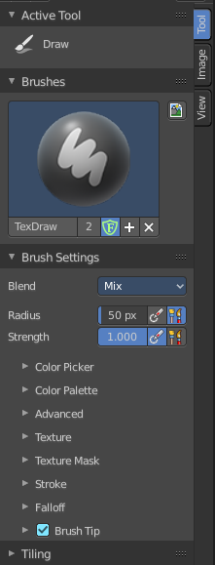
In View and Mask mode you don't have any further content in the Tool tab. But in Paint mode the tools tab contains several panels with functionality for the brushes. It is in big parts similar functionality to the paint tools in the 3D view.
The Brush panel shows different content, dependent of which brush is chosen in the tool shelf.

Save Image
A short warning. A modified image does NOT save with the scene. You have to save out the image when you want to save the changes at the texture. There is no warning. So DON'T FORGET TO SAVE THE IMAGE.

Brushes Panel
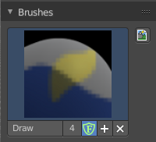
The Brush Panel contains the different Brushes and some Brush settings. Choose and adjust your current active brush.

Browse Brush
The big image at the top is a drop down box where you can see the current active brush. The content differs, dependent of the active brush. You can add duplicates of this active brush, and customize it to your needs. But the active brush gets chosen in the Tool Shelf at the left of the 3D View.
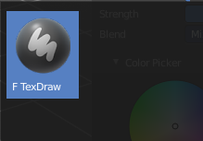
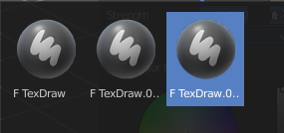
When you have added a few more brushes then the drop down box may be more than full. You will see some little white arrows then. Either in the top left or in the bottom right corner. They indicate that some brushes are hidden before or after the current display.
To scroll to this hidden content use the mouse wheel, or the arrow up and down buttons at the keyboard.

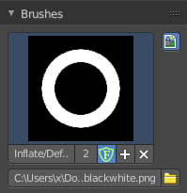
Custom Icon
The button at the right allows you to load a custom icon for your brush. It reveals a file browser below the image browser.

The edit box below the Image shows you the name of the current active brush.
The number right of it, in this case 2, indicates how much number of users ( internally ) this brush uses. This means that this data block (the brush) shares currently settings with at least one other object. Most probably the parent brush where we have created it from. Click at the value to make this brush a single user. The button will vanish then.
The shield icon set the brush to have a fake user. Zero user data-blocks are normally not saved. But sometimes you want to force the data to be kept even when the data block has no user.
The + button allows you to add a new pencil with the current settings. Note that the brushes are NOT saved when you close Bforartists. You can save them into the current blend file. Or you can save the startup file. But be careful here. This saves everything else of the current state of Bforartists too.
The X button deletes the brush as the active one. It does NOT delete it from the brushes list.

Brush settings Panel

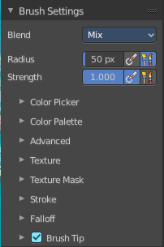
Brush Panel
The Brush Panel contains the different paint brushes, a color dialog, and some brush settings.

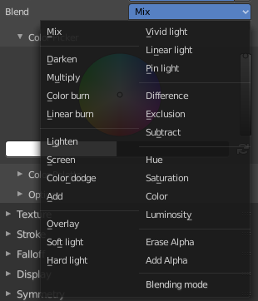
Blend
Define how the stroke will blend. You can choose between various blend modes.

Radius
The Radius edit box allows you to adjust the radius of the brush. The button behind the edit box enables tablet pressure sensitivity for radius.

Size Pressure
The first button behind the edit box enables tablet pressure sensitivity for radius.

Use Unified Radius
The second button behind the edit box enables global radius size. Any modification at the radius will also modify the radius value for other paint tools.

Strength
The Strength edit box allows you to adjust the strength of the brush. The button behind the edit box enables tablet pressure sensitivity for strength.

Size Pressure
The first button behind the edit box enables tablet pressure sensitivity for radius.

Use Unified Radius
The second button behind the edit box enables global radius size. Any modification at the radius will also modify the radius value for other paint tools.

Brush Settings Panel - Color Picker Sub panel
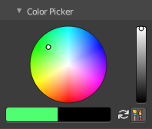
Define the color for your brush.
The active color is the left one. When you click the button with the two arrows down right then you can swap the color with the secondary color. Then this secondary color becomes the primary color, and is active.

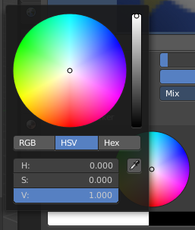
A click at one of the color fields will open a more detailed color dialog, to set up the color by using rgb, hsv and hex colors and with value sliders.

Brush colors flip
Flips the primary color with the secondary color.

Use unified Color
Choose if you want to use global colors or local color just for vertex painting.

Brush Settings Panel - Color Palette Sub panel

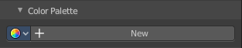
Create a color palette for later reuse.
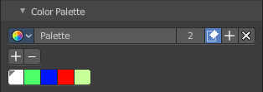
First create a new palette by clicking at New. Then adjust the color in the color picker. And then click at the add button to add this color to the palette.
To set the color picker to a palette color simply click at this palette color.
To remove a color from the palette, choose it, then click at the remove button. The active palette color that gets removed is the one with the triangle at it.
The color palette cannot be saved externally. It is part of the current blend file. You can however append color palettes from other blend files.
The elements are explained from left to right.

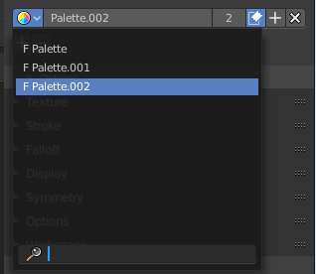
Palette browser
The button at the left opens a drop down list where you can choose between your palettes.

Edit Box
Read the name of the currently active palette. You can also rename the palette here. A click into the edit box makes the name editable.

Number of users
See how many users the palette currently has.

Fake User
Fake User sets the element to have a fake user. Zero user data-blocks are normally not saved. But sometimes you want to force the data to be kept even when the data block has no user.

Add palette
Add a new palette.

Remove Palette
Clicking at this button removes the palette. Note that you need to save, close Bforartists and reload the blend file to remove the palette completely.

Brush Settings Panel - Advanced Sub panel
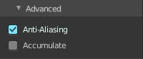
This sub panel contains brush specific settings.

Accumulate
Accumulate stroke daubs on top of each other.

Affect Alpha
When disabled then the alpha is locked while painting.

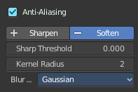
Sharpen / Soften (Soften Brush)

Sharp Threshold
The threshold below which no sharpening is performed.

Kernel Radius
Radius of kernel used for soften and sharpen in pixels.

Blur Mode (Soften Brush)
Choose the blur method. Gaussian or Box.

Image (Clone Brush)
Choose an image to clone from.

Alpha
The alpha value for the clone image.

Anti Aliasing
Smooths the edges of the strokes.

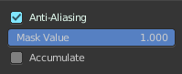
Mask Value (Mask brush)
The vertex weight when brush is applied.

Brush Settings Panel - Texture Sub panel
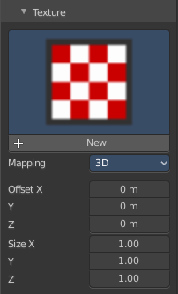

Texture Panel
The Texture panel allows you to paint with textures. This allows you for example to grab a photo from some fish scales, and simply paint them onto the mesh by using this image as a pencil. Or as a blueprint where you calk through ( Stencil method ).

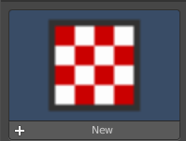
Browse Texture to be linked
The image at the top of the panel is an image browser. Choose a texture that you can choose for painting then. You can also have more than one image loaded at once.
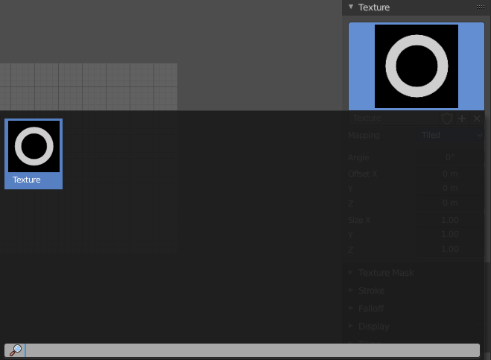
In this shot there is already a texture added. The way to add the texture here is a bit more complicated. And not done with clicking at the New button.

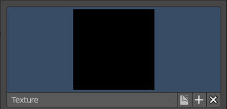
First click at the New button below the image. This will create a new texture slot. This slot is still empty, it displays black.

We need to load a texture in this slot. This must be done in the Properties editor in the Textures tab.

The problem is, we have an object with a material and a texture already selected. And when we change this texture , then we don't get the pencil texture loaded. But we change the texture at our mesh.

What we need to do is to create a material first. And in this material we load our pencil texture then. And then this texture becomes available in the image browser of the Texture panel.
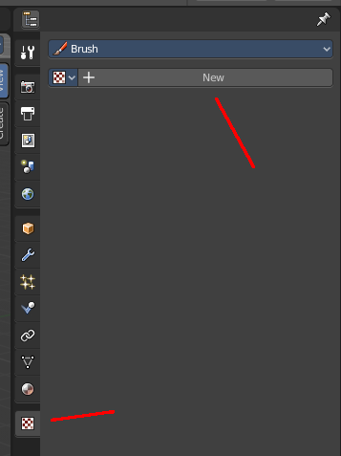
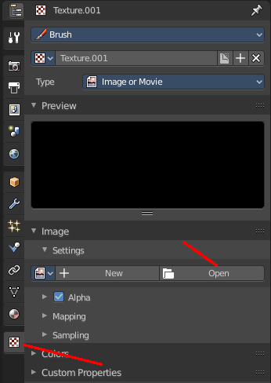
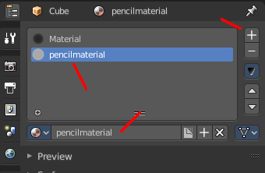
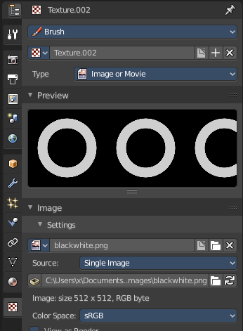

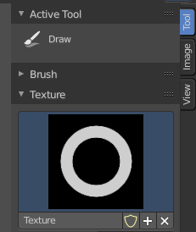
And when we go back to the texture panel, then the texture should be loaded here. And we can work with this texture.

Texture Edit box
The Texture edit box is the edit box below the Image browser. When there's no image loaded then it displays the New button. When there's an image (or more) loaded, then you will see the name of the current texture.
The F button turns this texture into a data block with a fake user. Means it will exists even when there is no data connected to it anymore.
When you activate Fake User, then you may get a value in front of it, which displays how much users this data block (our texture slot) currently has.
The + Button adds another texture slot. Note that you will have to load a texture too, as explained above.
The X button deletes the texture slot.

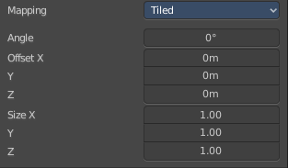
Brush Mapping
Our texture can be mapped in different methods. The Brush mapping is a drop down box where you can choose this different brush mapping methods.
The settings vary. So we will go through them by the different brush mapping methods.

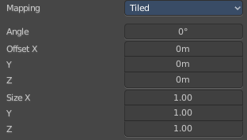
Brush Mapping with mapping method Tiled
The brush mapping method Tiled tiles the brush stroke at the surface. The mapping happens from the current view. The result may be distorted when the view does not align with the surface of the object.

Angle
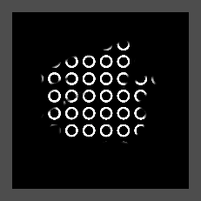
The angle of the brush.

Offset
The offset of the texture in the brush.

Size
The size of the texture in the brush.

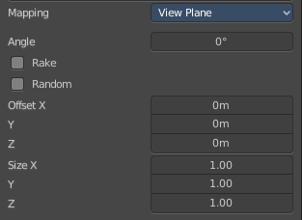
Brush Mapping with mapping method View Plane
The brush mapping method View Plane simply paints onto the surface. The mapping happens from the current view. The result may be distorted when the view does not align with the surface of the object.

Angle
The angle of the brush.

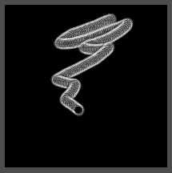
Rake
The angle follows the direction of the brush stroke.

Random
The brush angle gets set random.

Offset
The offset of the texture in the brush.

Size
The size of the texture in the brush.

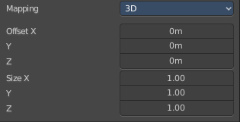
Brush Mapping with mapping method 3D
The brush mapping method 3D paints the texture at the surface, by tiling it 1/1 at the object surface.

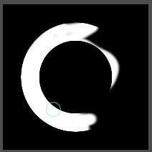
Offset
The offset of the texture in the brush.

Size
The size of the texture in the brush.

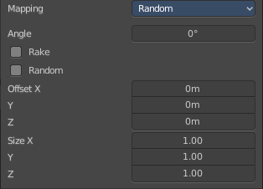
Brush Mapping with mapping method Random
The brush mapping method Random paints onto the surface, and randomizes the texture position in the brush while that. The mapping happens from the current view. The result may be distorted when the view does not align with the surface of the object.

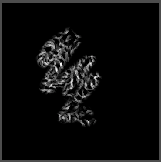
Angle
The angle of the brush.

Rake
The angle follows the direction of the brush stroke.

Random
The brush angle gets set random.

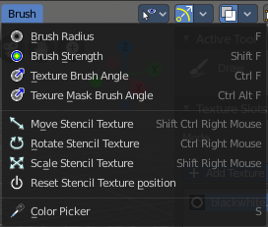
Brush Mapping with mapping method Stencil
The former methods uses the textures for the brush. The method Stencil works different. You have your texture displayed in the workspace above the object, and you paint this texture onto your object with your pencil strokes.
Note that the texture in the 3d space is just visible when you are with the mouse over the viewport.

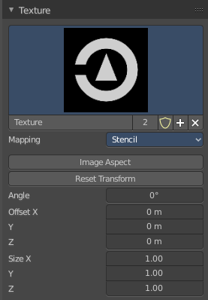
It gets by default displayed down left. You have to position it where you need it. See Brush menu in the 3D view, Stencil Texture controls.
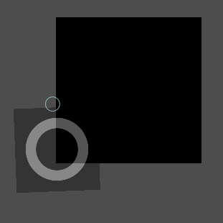

Image Aspect
Adjust the stencil size to fit to the image aspect ratio.

Reset Transform
Resets the stencil image to be down right in the 3D view.

Angle edit box
Adjust the angle of the brush. The button at the end allows you to set the radius by dragging the mouse. This should be done in the viewport and with the hotkey. This button is just a visible reminder.

Offset
Fine tune the offset of the texture in the brush.

Size
Fine tune the size of the texture in the brush.

Brush Settings Panel - Texture Mask Sub panel

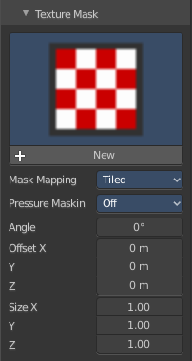
Texture Mask Panel
The texture mask panel allows you to use a texture as a mask to define the strength of painting. It paints just where the mask texture is bright. You can also use gradients to define the paint strength.

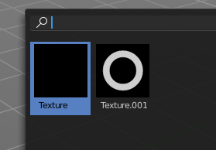
Browse Texture to be linked
The image at the top of the panel is an image browser. Choose a texture that you can choose for painting then. You can also have more than one image loaded at once.

In this shot there is already two textures added. The way to add the texture here is a bit more complicated. And not done with clicking at the New button.
First click at the New button below the image. This will create a new texture slot. This slot is still empty, it displays black.

We need to load a texture in this slot. This must be done in the Properties editor in the Textures tab.

The problem is, we have an object with a material and a texture already selected. And when we change this texture , then we don't get the pencil texture loaded. But we change the texture at our mesh.

What we need to do is to create a material first. And in this material we load our pencil texture then. And then we can choose this texture in the image browser of the texture.

And when we switch back to the tools tab, then the texture is loaded. And we can work with this texture.

Make sure that you use another texture in the Texture panel than in the Texture Mask panel, or no texture at all. When both is the same then you will get the same result with all Mask Mapping methods since they overlap each other at the very same positions.

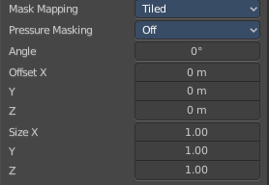
Brush Mapping with mapping method Tiled
The brush mapping method Tiled tiles the brush stroke at the surface. The mapping happens from the current view. The result may be distorted when the view does not align with the surface of the object.

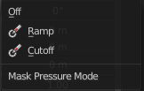
Pressure Masking
Enable pressure masking when you use a tablet.

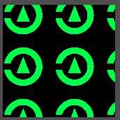
Angle
The angle of the brush.

Offset
The offset of the texture in the brush.

Size
The size of the texture in the brush.

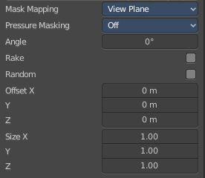
Brush Mapping with mapping method View Plane
The brush mapping method View Plane simply paints onto the surface. The mapping happens from the current view. The result may be distorted when the view does not align with the surface of the object.

Pressure Masking
Enable pressure masking when you use a tablet.

Angle
The angle of the brush.

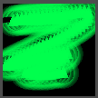
Rake
The angle follows the direction of the brush stroke.

Random
The brush angle gets set random.

Offset
The offset of the texture in the brush.

Size
The size of the texture in the brush.

Brush Mapping with mapping method Random
The brush mapping method Random paints onto the surface, and randomizes the texture position in the brush while that.

Pressure Masking
Enable pressure masking when you use a tablet.

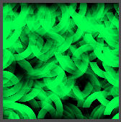
Mask Pressure Mode
A drop down box to choose the mask pressure mode for tablets.

Angle
The angle of the brush.

Rake
The angle follows the direction of the brush stroke.

Random
The brush angle gets set random.

Offset
The offset of the texture in the brush.

Size
The size of the texture in the brush.

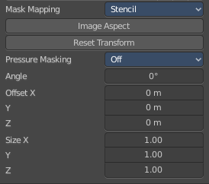
Brush Mapping with mapping method Stencil
The former methods uses the textures for the brush. The method Stencil works different. You have your texture displayed in the workspace above the image, and you paint this texture onto your object with your pencil strokes.
Note that the stencil texture is just visible when you are with the mouse over the viewport. It gets by default displayed down left. You have to position it where you need it. See Brush menu, Stencil Texture controls.

Image Aspect
Adjust the stencil size to fit to the image aspect ratio.

Reset Transform
Resets the stencil image to be down right in the 3D view.

Pressure Masking
Enable pressure masking when you use a tablet.


Angle edit box
Adjust the angle of the brush. The button at the end allows you to set the radius by dragging the mouse. This should be done in the viewport and with the hotkey. This button is just a visible reminder.

Offset
Fine tune the offset of the texture in the brush.

Size
Fine tune the size of the texture in the brush.

Stroke Panel

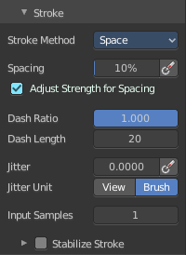
Stroke Panel
The Stroke panel contains settings to influence the behavior of the brush stroke. There are various stroke methods available. We will go through them one by one.

Stroke method Space
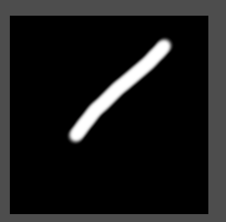
This is the default Stroke method. The stroke gets added continuously with given settings.


Spacing Edit Box
The sculpt drawing happens by mapping the pencil onto the mouse position. And when you move the mouse then the next mapping happens. Adjust the spacing after what mouse movement the next mapping should happen. The lower the value, the lower the distance between the single dots.

Spacing Pressure
The icon behind the edit box enables tablet pressure sensitivity for tablets.

Adjust Strength for Spacing
Automatically adjust strength to give consistent results for different spacing.

Dash Ratio
Ratio of samples in a cycle that the brush is covering.

Dash Length
Length of a dash cycle measured in stroke samples.

Jitter Edit Box
Add Jitter to the brush while painting.

Spacing Pressure
The icon behind the edit box enables tablet pressure sensitivity for tablets.

Jitter Unit
Jitter in screen space, or relative to the brush size.

Input Samples Edit Box
Average multiple input samples together to smooth the brush stroke.

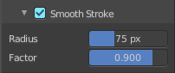
Smooth Stroke
The brush lags behind the mouse position, and produces a much smoother stroke by that.

Smooth Stroke Radius Edit Box
Is just active when Smooth Stroke is activated. Adjust the radius of the smoothing.

Smooth Stroke Factor Edit Box
Is just active when Smooth Stroke is activated. Adjust the factor of the smoothing.

Stroke method Curve
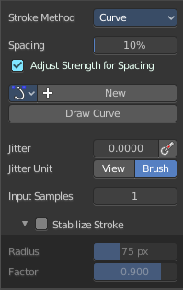
The Stroke method curve doesn't simply influence the way how the stroke is painted. It is a special method.
First you draw a curve object by holding down ctrl and clicking with right mouse button. Then you tweak the curve. You can click at the curve point, and drag out handlers to make the curve points smooth. This way you get one handler. When you click and drag then you will get two handlers at the curve point.
When done you hit the Draw Curve button or click left outside of the image. And the curve gets drawn onto the surface.
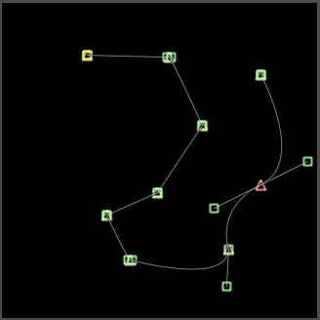
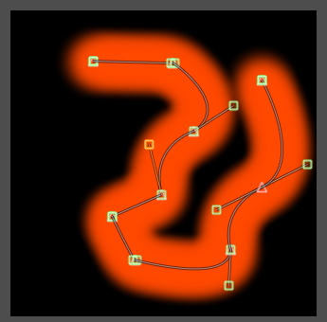

Spacing Edit Box
The drawing happens by mapping the pencil onto the mouse position. And when you move the mouse then the next mapping happens. Adjust the spacing after what mouse movement the next mapping should happen. The lower the value, the lower the distance between the single dots.
The icon behind the edit box enables tablet pressure sensitivity for tablets.

Paint Curve edit box
Here you set the active curve.
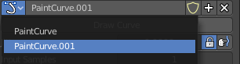
The first element is a drop down box where you will find your curves objects. You can have more than one.
The second element is the edit box that displays the active curve.
The number right of it, in this case 2, indicates how much number of users ( internally ) this brush uses. This means that this data block (the brush) shares currently settings with at least one other object. Most probably the parent brush where we have created it from. Click at the value to make this brush a single user. The button will vanish then.
F set the brush to have a fake user. Zero user data-blocks are normally not saved. But sometimes you want to force the data to be kept even when the data block has no user.
The + button allows you to add a new pencil with the current settings. Note that the brushes are NOT saved when you close Bforartists. You can save them into the current blend file. Or you can save the startup file. But be careful here. This saves everything else of the current state of Bforartists too.
The X button deletes the brush as the active one. It does NOT delete it from the brushes list.

Draw Curve Button
A click at it to turns the curve into curve.

Jitter Edit Box
Add Jitter to the brush while painting.

Jitter Pressure
The icon behind the edit box enables tablet pressure sensitivity for tablets.

Jitter Unit
Jitter in screen space, or relative to the brush size.

Input Samples Edit Box
Average multiple input samples together to smooth the brush stroke.

Stabilize Stroke
The brush lags behind the mouse position, and produces a much smoother stroke by that.

Smooth Stroke Radius Edit Box
Is just active when Smooth Stroke is activated. Adjust the radius of the smoothing.

Smooth Stroke Factor Edit Box
Is just active when Smooth Stroke is activated. Adjust the factor of the smoothing.

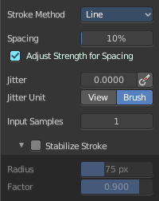
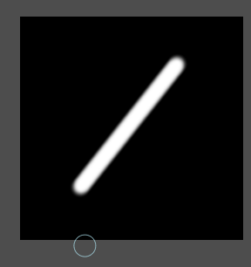
Stroke method Line
With Stroke method line you draw a line between a starting point and an endpoint. And when you release the mouse then the line gets drawn.

Spacing Edit Box
The drawing happens by mapping the pencil onto the mouse position. And when you move the mouse then the next mapping happens. Adjust the spacing after what mouse movement the next mapping should happen. The lower the value, the lower the distance between the single dots.
The icon behind the edit box enables tablet pressure sensitivity for tablets.

Jitter Edit Box
Add Jitter to the brush while painting.

Jitter Pressure
The icon behind the edit box enables tablet pressure sensitivity for tablets.

Jitter Unit
Jitter in screen space, or relative to the brush size.

Input Samples Edit Box
Average multiple input samples together to smooth the brush stroke.

Stabilize Stroke
The brush lags behind the mouse position, and produces a much smoother stroke by that.

Smooth Stroke Radius Edit Box
Is just active when Smooth Stroke is activated. Adjust the radius of the smoothing.

Smooth Stroke Factor Edit Box
Is just active when Smooth Stroke is activated. Adjust the factor of the smoothing.

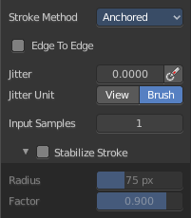
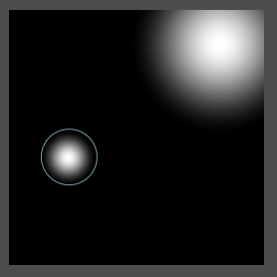
Stroke method Anchored
Click and drag to place a dot and to scale it.

Edge to edge
Drag Anchor Brush from edge to edge.

Jitter Edit Box
Add Jitter to the brush while painting.

Jitter Pressure
The icon behind the edit box enables tablet pressure sensitivity for tablets.

Jitter Unit
Jitter in screen space, or relative to the brush size.

Input Sample Edit Box
Average multiple input samples together to smooth the brush stroke.

Stabilize Stroke
The brush lags behind the mouse position, and produces a much smoother stroke by that.

Smooth Stroke Radius Edit Box
Is just active when Smooth Stroke is activated. Adjust the radius of the smoothing.

Smooth Stroke Factor Edit Box
Is just active when Smooth Stroke is activated. Adjust the factor of the smoothing.

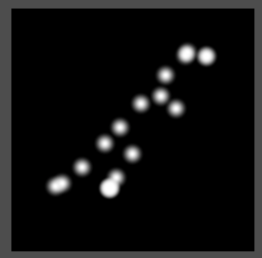
Stroke method Airbrush
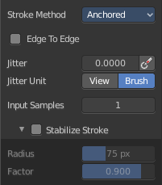
The stroke acts like an airbrush pencil. The dots gets placed randomly.

Rate Edit Box
Define the rate of the drawing.

Jitter Edit Box
Add Jitter to the brush while painting.

Jitter Pressure
The icon behind the edit box enables tablet pressure sensitivity for tablets.

Jitter Unit
Jitter in screen space, or relative to the brush size.

Input Samples Edit Box
Average multiple input samples together to smooth the brush stroke.

Stabilize Stroke
The brush lags behind the mouse position, and produces a much smoother stroke by that.

Smooth Stroke Radius Edit Box
Is just active when Smooth Stroke is activated. Adjust the radius of the smoothing.

Smooth Stroke Factor Edit Box
Is just active when Smooth Stroke is activated. Adjust the factor of the smoothing.

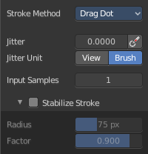
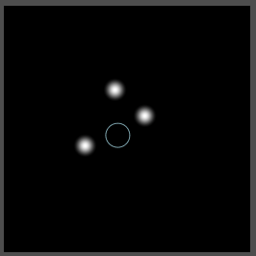
Stroke method Drag Dot
Paint a dot and drag it around. The actual painting happens then at releasing the mouse.

Jitter Edit Box
Add Jitter to the brush while painting.

Jitter Pressure
The icon behind the edit box enables tablet pressure sensitivity for tablets.

Jitter Unit
Jitter in screen space, or relative to the brush size.

Input Samples Edit Box
Average multiple input samples together to smooth the brush stroke.

Stabilize Stroke
The brush lags behind the mouse position, and produces a much smoother stroke by that.

Smooth Stroke Radius Edit Box
Is just active when Smooth Stroke is activated. Adjust the radius of the smoothing.

Smooth Stroke Factor Edit Box
Is just active when Smooth Stroke is activated. Adjust the factor of the smoothing.

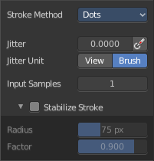
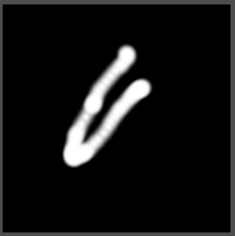
Stroke method Dots
The stroke method Dots draws dots of the pencil onto the surface. The mapping happens from the current view. Means you will get distortions when your view is not aligned with the surface of the object.

Jitter Edit Box
Add Jitter to the brush while painting.

Jitter Pressure
The icon behind the edit box enables tablet pressure sensitivity for tablets.

Jitter Unit
Jitter in screen space, or relative to the brush size.

Input Samples Edit Box
Average multiple input samples together to smooth the brush stroke.

Stabilize Stroke
The brush lags behind the mouse position, and produces a much smoother stroke by that.

Smooth Stroke Radius Edit Box
Is just active when Smooth Stroke is activated. Adjust the radius of the smoothing.

Smooth Stroke Factor Edit Box
Is just active when Smooth Stroke is activated. Adjust the factor of the smoothing.

Brush Settings Panel - Falloff Sub panel
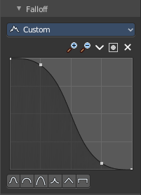
The curve panel allows you to define different falloffs methods for the border of the brush.


Selecting Points
You can select curve points. This reveals two edit boxes for the x and y coordinate of this point.
Selected points can be moved around. Left click at them, hold the mouse button down and move them to a new location.


Adding Points
You can add new curve points by simply left clicking at the curve. Move the mouse to position them where you need it.

Navigation elements
The navigation elements at the top are described from left to right.

Zoom in and out
The two buttons with the magnifying glass at it zooms in and out in the curve window.

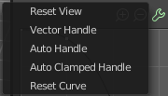
Tools
Tools is a menu where you can find some curve related tools.

Reset View
Resets the curve windows zoom.

Vector Handle
Set handle type to Vector.

Auto Handle
Set handle type to Auto.

Auto Clamped Handle
Set handle type to Auto Clamped.

Reset Curve
Resets the curve to the initial shape.


Use Clipping
Clipping options. Set up clipping for the stroke.

Delete Points
Deletes selected curve points.

Curve window
Tweak and adjust the falloff curve by clicking at a curve point and dragging it around.
Double click adds a new point.
Holding down ctrl activates temporary snapping.
Holding down shift enables slower movement, which allows more accurate setting.


Curve Presets
Predefined curve presets.

Brush Settings Panel - Brush Tip Sub panel

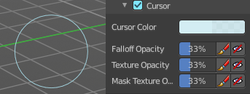
Adjust the color and appearance of the brush cursor to custom values.

Brush Tip Checkbox
Activate the custom settings.

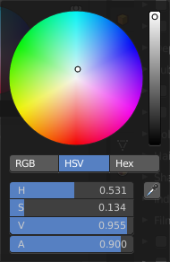
Cursor Color
Choose another color for the brush cursor. Double clicking at the color field will open a color picker.

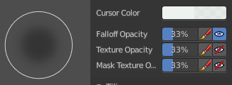
Falloff Opacity
You can turn on the cursor overlay with the eye button at the end. The falloff opacity slider allows you to adjust the opacity of this cursor overlay.

Override Overlay
Hide the Cursor Overlay when painting.

Use Cursor Overlay
Turn on Cursor Overlay.

Texture Opacity
This is for the case when you paint with a texture brush. You can turn on the Texture overlay with the eye button at the end. The falloff opacity slider allows you to adjust the opacity of this cursor overlay.

Override Overlay
Hide the Texture Overlay when painting.

Use Cursor Overlay
Turn on Texture Overlay.

Mask Texture Opacity
This is for the case when you mask paint with a texture brush. You can turn on the Texture overlay with the eye button at the end. The falloff opacity slider allows you to adjust the opacity of this cursor overlay.

Override Overlay
Hide the Texture Overlay when painting.

Use Cursor Overlay
Turn on Texture Overlay.

Tiling panel

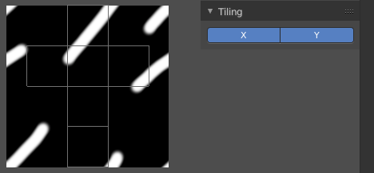
Tiling allows you to draw over the borders and continue the stroke at the other side of the image. You can tile in X and Y direction.

